WORDPRESS ASSIGNMENT

PHOTOGRAPHY EVENT MANAGEMENT

A-TITLE-PHOTOGRAPHY EVENT MANAGEMENT

B. INTRODUCTION:

This is photography website who has recently launched an event online in which is in offline mode, this creation of website has lead to big publicity of the event and organizers are at great benefit

The forms are created and displayed on the website ,the website consists of 5 pages and 3 forms accordingly. These forms are user friendly and can be understood easily.

C.SHORT INFO OF 5 PAGES

Pg-1-HOME PAGE

photographs preview which will be at the sale.

Pg-2-PORTFOLIO PAGE

The displayed photos of some really good photographers

Pg-3 ABOUT US:

Here we have displayed who founded the website and also a registration form is provided to register for the event.

Pg-4-HOW’S THE EVENT:

A feedback form is provided in this section, this is for organizers of the event, and these reviews could be beneficial for the organizers.

Pg-5-CONTACT ME:

Lastly, an attendance form is created and printed in this section, here customers can comment on the event they attended.

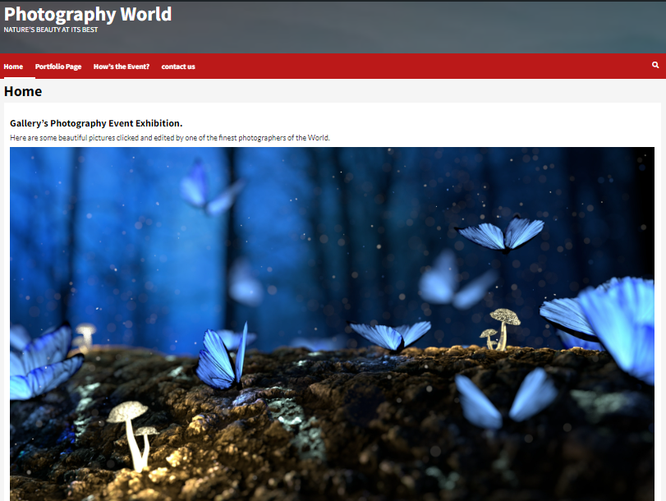

HOME PAGE

pg. 1-Homepage

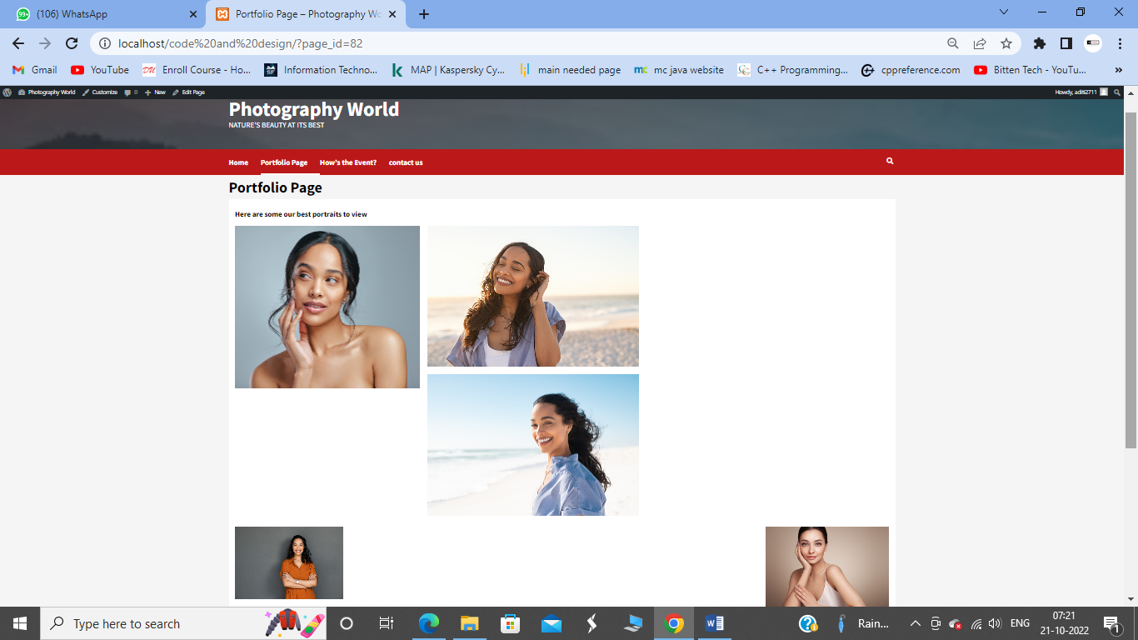

Pg-2 Portfolio

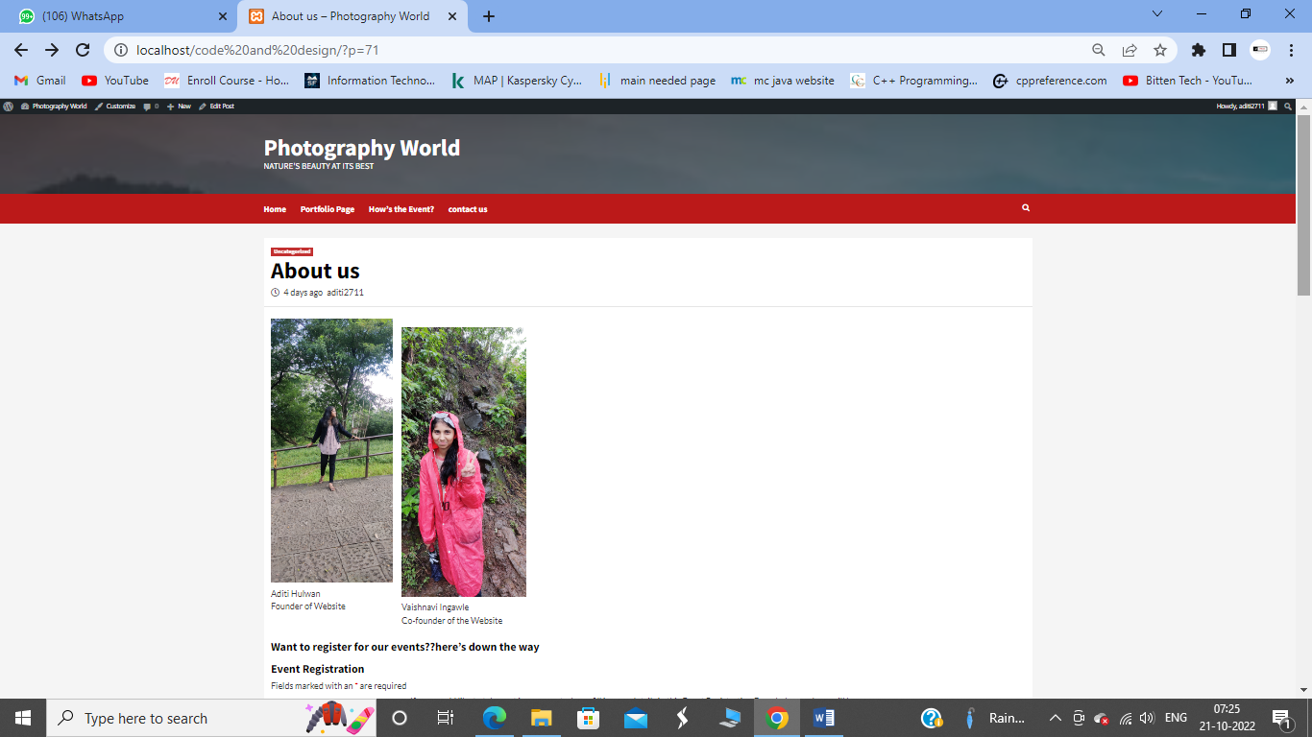

Pg-About us

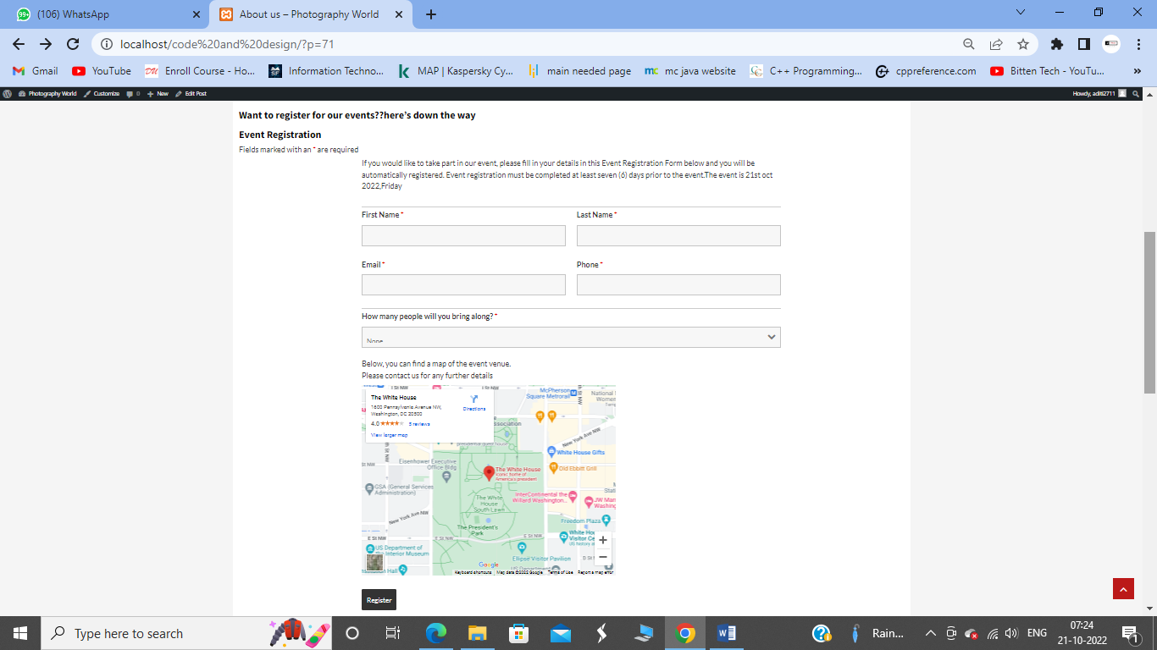

Event registration form

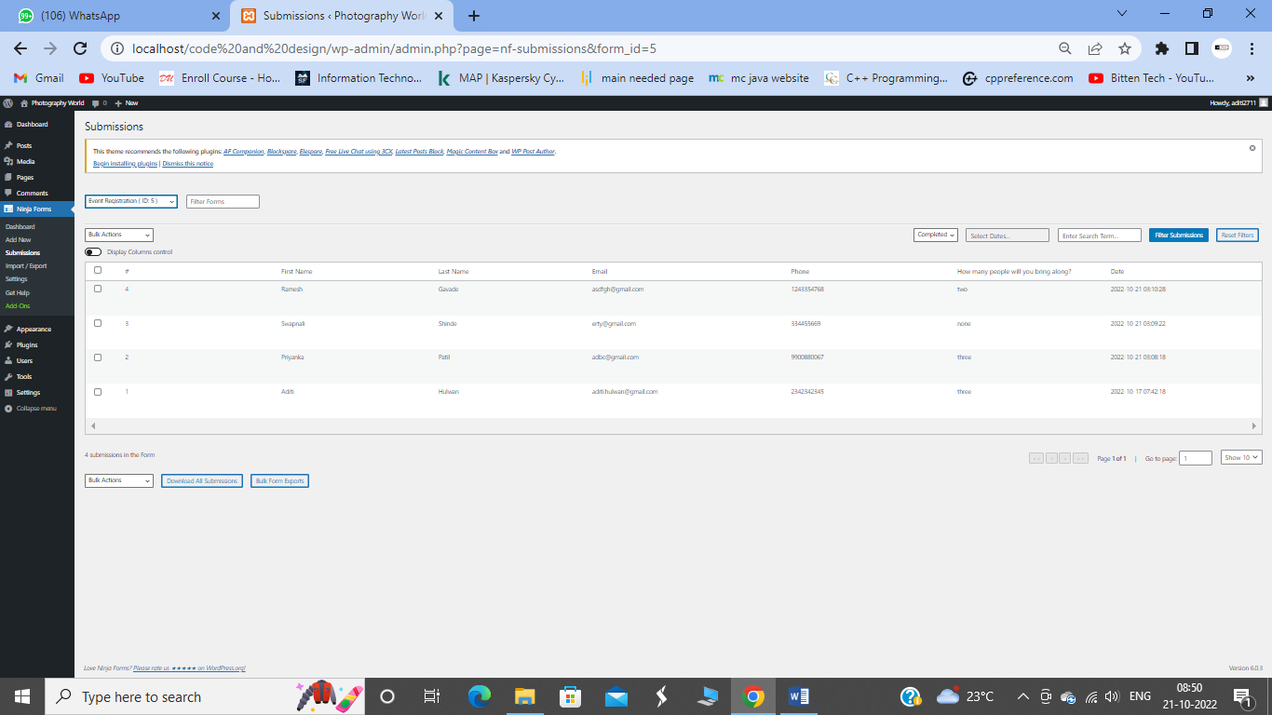

Regestration form Backend Data.

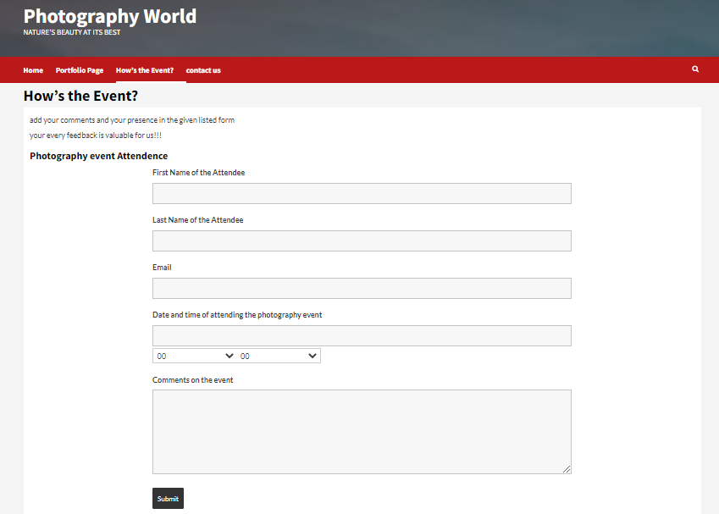

Pg-4-How’s the event+ attendance form

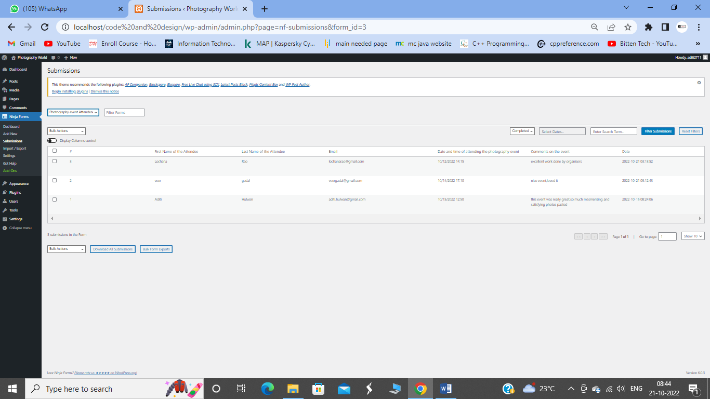

Backend data stored

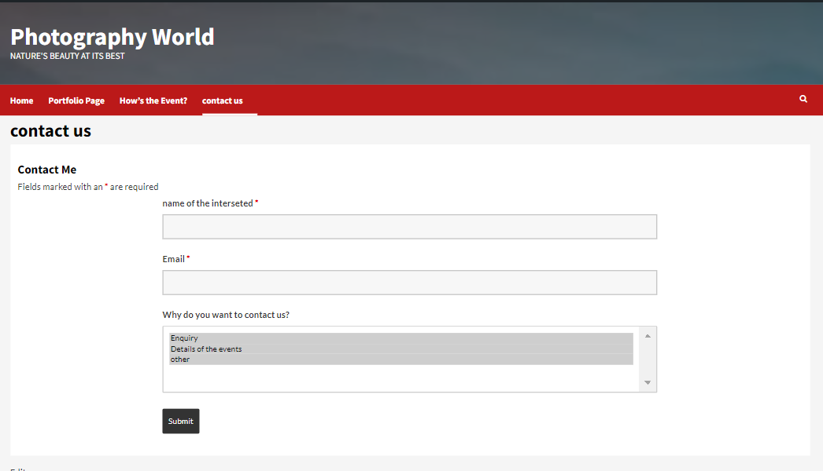

Pg-5-Contact us +feedback form.

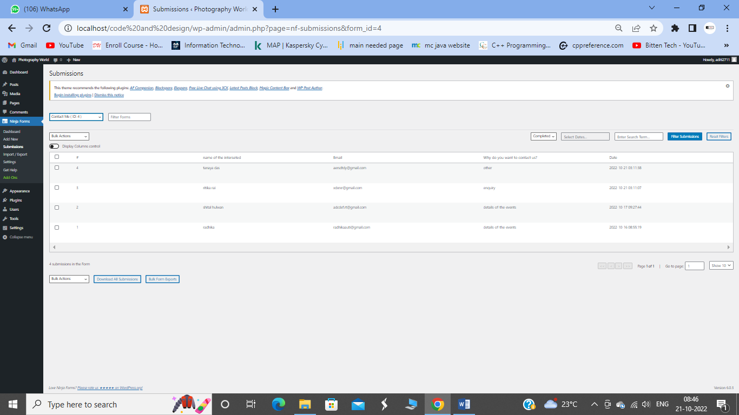

Contact form backend data